RAJNEESH KUMAR SINGH
Contact Nos.: 08795465000 ~ E-Mail: rajneesh261@rediffmail.com
Contact Address: New Colony, Mishraulia, Rauza , Ghazipur 233001 (U.P.)

Proactive Professional with a demonstrated record of achievement in conceiving & implementing ideas that fuel market place presence and drive revenue, seeking senior level assignments in Business Development/ Sales & Marketing with an organisation of high repute preferably in Automobile, FMCG and Consumer Durables

WORK EXPERIENCE

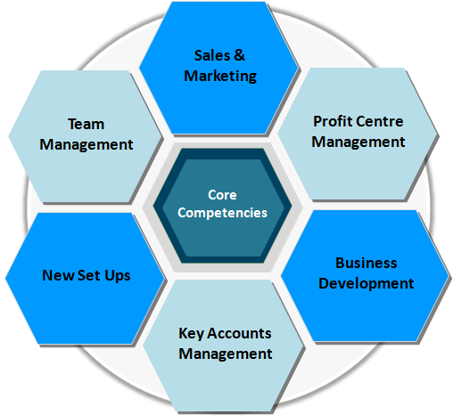
- Over 13 years of experience in Sales & Marketing, Business Development, Brand Management, Product Promotions & Launches, Customer Relationship Management and Team Management
- Expertise in networking with prospective clients while simultaneously generating business from existing accounts
- Adept in initiating & developing relationships with key decision-makers in target organizations for business development
- Deft in breaking new avenues and conducting opportunity analysis by keeping abreast of market trends and competitor moves
- Pivotal in implementing strategies for building team effectiveness by promoting a spirit of cooperation between team members
- A keen planner, strategist and implementer with deftness in devising and implementing strategies aimed at ensuring effectiveness of operations, realization of sales & business promotion targets, with key focus on ROI
- Creative and Multi-disciplinary Executive renowned for building brand and enhancing its visibility using all forms of brand communication thereby growing brands sales and launching products
- Proven leader with outstanding relationship building skills, strong communication abilities and exceptional emotional intelligence that excels in matrix and hierarchical structures

CORE COMPETENCIES

- Executing profitable & productive business relationships and building an extensive client base with distinction of accomplishing multi-fold revenue increase
- Monitoring strategies to enlarge the core market base of the company based on market research data while conceptualizing, planning and implementing processes to drive business volume growth
- Providing visionary leadership in assessing client needs and strategically positioning products to achieve specific objectives
- Adhering to all company policies, procedures and business ethics codes while ensuring that they are communicated and implemented within the team
- Increasing demand in the market by implementing consumer loyalty programs/ strategies to improve the product awareness in markets
- Overseeing complete business operations with accountability of profitability, forecasting monthly/ annual sales targets, & executing them in a given time frame

WORK EXPERIENCE
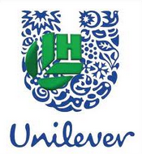
Senior Sales Officer with Hindustan Unilever Ltd., Gorakhpur Rural Since Mar’13

Accomplishments
- Significantly handled Gorakhpur, Sant Kabirnagar,Mahrajganj District and streamlined distribution in Gorakhpur Urban and Rural and turnover is approx 2.75 Crore per month now which was 1.5 Crore at the time of joining
- Bagged "Taza club Award" for topping east UP rural region in sales
- Merit of planning mid-day meal for the small children for soupy noodles in schools which is still doing well better than Maggie soupy noodles which was not doing well in the Ajmer market when company launched
- Assisted and mentored the 3P person & instrumentally made the person on roll

Asst. Manager with Aircel Ltd., Location Apr’12 to Mar’13

Accomplishments
- Efficiently looked after activation of UAO, URO, DAO and revenue at Udaipur DHQ
- Competently handled responsibility of two rural TSM based at Rajsamand and Banswara and 3 PSR based at Fatehnagar, Dungarpur and Rishabhdev
- Professionally looked after new infra expansion called Hellow way to Highway by appointing Neeli Dukan at every single BTS town on Udaipur to Rajsamand Highway
- Significantly focused on leading operations Go Green at DHQ by making more than 350 URO where competition was serving and appreciated by organization
- Played a stellar role in:
- Developing commercial partnerships and solid business relationship, by maintaining a contact strategy that ensured good customer follow up
- Submitting business proposals, meeting monthly targets and preparing daily activity reports

Territory Sales Officer with Hindustan Unilever Ltd., Location May’08 to Apr’12

Accomplishments
- Acknowledged for spearheading sales & marketing operations for FMCG products and achieved business goals and sales growth
- Capably worked in Ajmer Rural by handling Ajmer RD and three LAB RS Kuchaman Nagaur and Merta city turnover of 2.3 crore per month and also worked in Jaipur Rural in April 2012 for one month
- Reviewed & interpreted competition & market information to fine tune the marketing strategies
- Built and strengthened relationships with distributors, whole sellers, thereby ensuring high customer satisfaction by providing them with complete product & service support
- Merit of setting-up of new distribution model called “Xpress” with Tata DOCOMO in Jaipur rural

PREVIOUS WORK EXPERIENCE

Territory Sales In-Charge with Mother Dairy Fruits & Vegetables Pvt. Ltd., Ghaziabad Aug’04 to Mar’O8
Growth Path:
Aug’04 to Mar’07 Territory Sales In-charge, Ahmedabad
Apr’07 to Mar’O8 Territory Sales In-Charge, Ghaziabad

Successfully handled 7 Distributors across BVM Milk Channel and more than 500 Private Retail Shops in NCR region (Ghaziabad)

Marketing Executive with Kota Zila Dugdha Utpadak Sahkari Sangh Ltd., Kota Mar’02 to Dec’O5 Please provide logo
Launched SARAS Doodh in Kota's upcountry area likes in villages; promoted this packet milk, tied up with hospitals to spread awareness and this boosted the revenue

ACADEMIC DETAILS

2001 MBA (Marketing Management) from TERI, P.G. College Ghazipur (U.P)

1999 B.A. (English Sanskrit and History) from Purvanchal University, Jaunpur

IT SKILLS

- Well versed with MS Office and other Internet Applications

PERSONAL DETAILS

Date of Birth: 5th July 1978
Languages Known: English, Hindi, Marwari and Gujarati
Location Preference: North India

